
SAS and The Arab Academy for Management Banking and Financial Sciences

proudly recognize
{Name}

for successful completion of the requirements for
SAS® Academic Specialization in {Certificate Name}
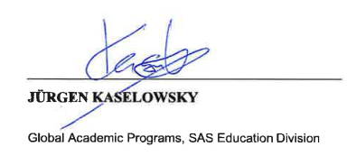
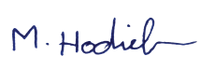
on {Date}

Dr. Mostafa Hodieb

President
The Arab Academy for Management Banking and Financial Sciences

